Media Release  1 MARCH 2021 | 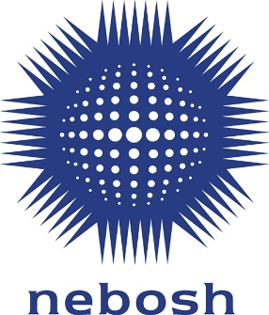
NEBOSH launches new fire safety qualification

NEBOSH, one of the world’s leading health and safety awarding bodies, has launched a new globally relevant fire safety qualification which can be completed in just one week! The NEBOSH Certificate in Fire Safety helps learners develop practical fire safety skills that can be used to protect people, buildings and business.

The syllabus covers a broad range of topics including the principles of fire and explosion, how to identify fire hazards in the workplace and the controls that can be put in place to reduce risk.

With the changes to the workplace and ways of working that the COVID-19 pandemic has brought, it’s even more important to bring your teams up to speed with global best practice in fire safety.

The qualification, which is suitable for low to medium risk workplaces, offers businesses a great way to build in-house fire safety expertise. Health and Safety Managers, facilities personnel and safety representatives can all benefit from the specialist fire safety knowledge covered in the course.

Dee Arp, NEBOSH Chief Operating Officer said: “The qualification’s content and assessment aim to help learners gain practical skills and knowledge. The two-part assessment consists of an open book examination and fire risk assessment practical. Both give learners the opportunity to practice what they have learnt so they can immediately make a positive contribution to fire safety in their workplace.”

Learners sitting the NEBOSH Certificate in Fire Safety will register and study with an accredited Learning Partner, before completing the two assessments. The open book examination will present a realistic workplace scenario, allowing learners to apply their knowledge to the situation described and demonstrate what they have learned.

The practical fire risk assessment reflects relevant fire assessment standards and is a second opportunity for learners to demonstrate the practical knowledge they have gained through their studies and revision.

As the assessments can be completed remotely, the NEBOSH Certificate in Fire Safety offers increased flexibility for Learners and organisations looking for distance and elearning solutions.

The NEBOSH Certificate in Fire Safety will replace both the current UK and International NEBOSH Certificates in Fire Safety and Risk Management. It can be studied from 1 May 2021 through NEBOSH’s global network of accredited Learning Partners.

For more information visit: www.nebosh.org.uk/fire

- ENDS -

Notes to Editors

About NEBOSH

NEBOSH is a leading global brand in health, safety, wellbeing and environmental qualifications. Internationally recognised qualifications help to raise the competence of safety and environmental professionals as well as individuals at all levels in the workplace.
Since its inception in 1979 more than half a million people from around the world have studied for a NEBOSH qualification. Tens of thousands join their number every year studying with our network of 600 learning partners in over 132 countries.
NEBOSH qualifications are highly respected by governments, employers and our learners. They build the knowledge and skills which underpin competent performance as a health, safety and environmental professional. NEBOSH qualifications are recognised by all the relevant professional membership bodies.
In 2014, NEBOSH received a Queen’s Award for Enterprise for Outstanding Achievement in International Trade in recognition of our international success.
Contact
For more information please contact:
Jenny Pratt, NEBOSH Head of Communications
Tel: +44 (0)116 2634742
jenny.pratt@nebosh.org.uk

